ur

Lean Technologies
Change and Patch Management Process

Approving Authority | RCC
Prepared By | Head of InfoSec
Approval Date | March 2025
Next Scheduled Review | March 2026
Description | This document provides a consolidated process to minimize risks and disruptions to Lean services while making changes to critical systems and services.
Version | Published

Contents
Table of Contents
1. Overview 3
1.1 Objective 3
1.2 Scope 3
2. Change management process overview 3
2.1 Change management process steps 3
2.2 Change Request Types 4
2.2.1 Based on the severity and urgency of the request 4
2.2.2 Based on the affected systems or services 5
2.3 Approval Matrix 5
2.4 Change advisory board (CAB) 6
3. Change Management Workflow 7
3.1 JIRA Change Management Flow 7
3.2 Assessing risk of the change request in JIRA 8
3.3 Integrating Change Requests in the CI/CD pipeline (automatic process) 8
3.4 Compliance Measurement and Evaluation for Change Management Security Controls 9
Appendix A – HotFix Procedure (manual Process) 9

Overview

Objective
The document provided a change management process designed to minimize risks and disruptions to Lean services while making changes to critical systems and services. A change is adding, modifying, or removing anything that could have a direct or indirect effect on services.

Scope
Change Management process covers changes to systems across Lean services and systems. It includes requests for program changes, system changes, system maintenance, and administration access

Change management process overview
Lean change management process is shifting away from lengthy reviews and non-technical stakeholder approvals and toward automated, collaborative processes between DevOps and development teams that increase agility while still balancing risk.

2.1 Change management process steps
- Identify need for changes:
  - Gather data from different sources to understand a specific need for change
  - Evaluate if a potential change is needed and should be managed
  - Prioritize which potential changes you further want to investigate and qualify
- Qualify Changes & Assess Change Impact
  - Assess the impact the change has on all affected stakeholders and affected systems
  - Assess the change type (standard, normal, emergency), priority, security risk level,
  - Identify first change actions to realize the change and the shift from the current to the desired target state
  - Define criteria which will help to evaluate the change success
  - A change manager or peer reviewer reviews the initial change request. How likely is it to be successful? Are the risks and rewards accurate? Is it worth making?
- Plan, Orchestrate & Implement
  - Change plan - The team creates a game plan for the change. They document expected outcomes, resources, timeline, testing requirements, and ways to roll back the change if needed.
  - Change approval -Based on the change type (standard, normal, emergency) different stakeholders will need to approve the change (peer reviewer, product owner, security, DevOps, Engineering lead)
  - Change implementation -The team ships the change, documenting procedures and results along the way. Depending on the security risk level of the change and affected components, additional security activities will need to be conducted:
    - Penetration testing;
    - Code review if applications are developed internally.
    - Code review of externally developed applications and if the source code is available
    - A code review report (or equivalent, such as an independent assurance statement) in case the source code cannot be provided;
  - Communication - Once change actions and measures are prepared the communication and implementation of the changes need to be planned and prepared. make sure that changes will get required attention, that they are understood, accepted and that people act upon them (a dedicate Slack channel exists at Lean, for this communication: #change-management)
  - Change closure - When appropriate, the change manager reviews and closes the change when appropriate. Their report should communicate whether the change was successful, timely, accurately estimated, within budget, etc.
  - (If applicable) In case the change was not successful, a roll-back procedure will be implemented and the failure of the change management will be analyzed The change management process will start again from step no 3.
- Review and Evaluate
  - Review the KPIs and evaluation criteria which you have defined in the change qualification phase
  - Gather data for the respective KPIs
  - Assess changes with respect to pre-assessed baseline

2.2 Change Request Types

2.2.1 Based on the severity and urgency of the request
Standard
A standard change is a pre-authorized change that is low risk, relatively common and follows a specified procedure or work instruction.
- A standard change is one that is frequently implemented, has repeatable implementation steps, and has a proven history of success.
- Standard changes have to go through the change management process.
- Do not require any authorization or peer review
Normal
A normal change is high risk, high impact, or has a more complex procedure.
- All changes to complex applications also are considered comprehensive due to the type of systems that they affect and the potential impact that could occur if there is an issue.
- Infrastructure changes are also considered comprehensive.
- They require sever approvals (see Approval Matrix).
Emergency/ HotFix
An emergency change follows the same approval process as Normal except for the Initiate step, which is skipped in order to speed up the process(see Change Management Workflow)
- It can be entered for approval after the change has been implemented in production.
- Emergency changes are intended to be used only where there is an immediate critical need to correct an operational or security issue that is preventing users from working or transactions to not be processed or processed incorrectly.
- They require review and all approvals after the change has been implemented.
Note: The procedure to rollout a HotFix on Production is detailed in Appendix A.

Based on the affected systems or services
Infrastructure changes
- All changes to infrastructure are managed by Terraform
- If the CR is identified to have a security impact, an Infrastructure vulnerability assessment and/or penetration testing will be conducted
- Stress testing is performed where appropriate, in order to measure different scenarios related to expected user load
- Approval are required on the GitHub level to merge the branch into master & apply to the environment
Code/Release Changes and HotFixes – following checks are being conducted:
- SonarQube for static analysis of code to detect bugs, code smells, security vulnerabilities
- Jenkins CI tests
- Integration tests ,
- Peer reviewal,
- Container security scanning

2.3 Approval Matrix
Approval Type | Description | Standard | Normal | Emergency/HotFix
Peer Review | Peer Reviews are performed by a peer of the change Requestor or Developer and are intended to identify any potential issues with the planned change or change process.  Note: The peer review process was established to mitigate the risk of the lack of segregation of duties between developer and implementer. The review provides comfort that changes to the production environment are valid. | No | Yes | Yes
Head of Engineering | The Head of Engineering must approve all Emergency changes or HotFixes | No | No | Yes
Head of Security | The Head of Security needs to be involved if the change request is identified to have a security risk | No | Yes* | Yes*
Chief Technology Officer | Ultimately responsible with all technical aspects of the systems under change management. | No | No | Yes
Head of DevOps | The Head of DevOps responsible with the implementation of the change | No | Yes | Yes
*Only if the change request is identified to have a security risk.

2.4 Change advisory board (CAB)
A change advisory board (CAB) is tasked with assessing the risks of and approving (or not approving) each change. Typically, the CAB holds regularly scheduled meetings to review all proposed upcoming changes, pulling in experts as needed to explain, defend, or assess the change with them.
On one hand, change advisory boards can help reduce risk and raise the alert when a change simply won’t work for the company. On the other hand, they can also create a bottleneck—especially when they’re made up of people who aren’t close to the changes being deployed. In many enterprises, the change advisory board (CAB) approval process is complex and time-consuming, which slows down the change process.

At Lean , we have a decentralized CAB where the approval is split so that required activities can be done in parallel by the different involved teams. Our decentralized CAB is formed out of (see below printscreen as well):
- TFT Review (Lean architecture team )
- Security Review
-DevOps (infrastructure team)
-CTO sign-off
-CPO signoff

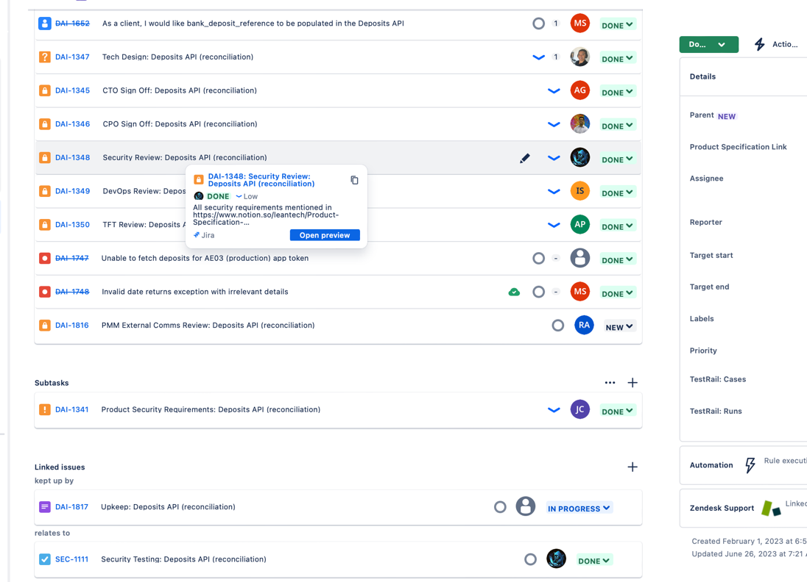

2.5 Service Level Agreement (SLA)
Following Service Level Agreement are defined and followed:
ID | Change Request Type | SLA
1 | Standard | N/A
2 | Normal | <48h
3 | Emergency/ HotFix | <24h

Change Management Workflow

3.1 JIRA Change Management Flow
At Lean, we use JIRA Service Management for Change Management.

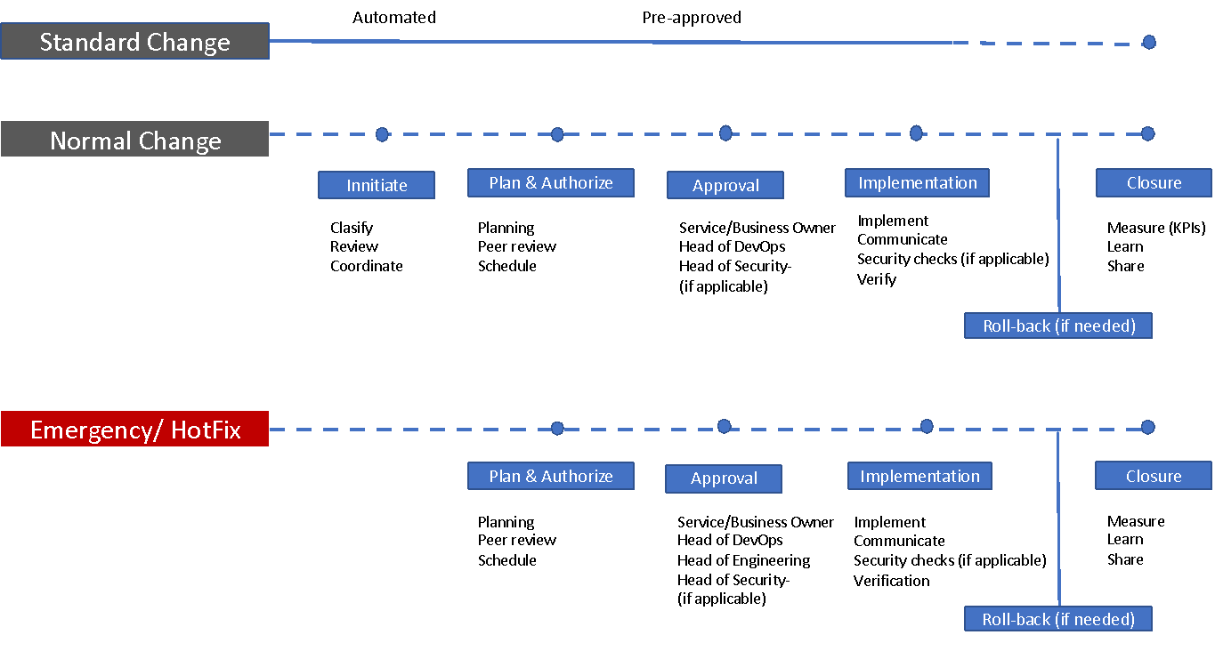

3.2 Assessing risk of the change request in JIRA
The request form in Jira Service Management allows to configure the questions and data needed to properly assess the risk of a change. Based on the responses, automation in Jira Service Management can be used to calculate the level of risk of each change request and set the appropriate risk value.
Automation is used also to:
- Classify a change request as ‘standard,’ ‘normal,’ and ‘emergency,’ or by service tier and dependencies.
- Route change requests down the right Jira workflow path, such as pre-approvals for standard changes and additional workflows for high-risk normal changes
- Notify assigned stakeholders about high-risk changes which require further review and/or security testing

3.3 Integrating Change Requests in the CI/CD pipeline (automatic process)

By integrating Jira Service Management with Jenkins CI/CD tools ,developers now have a streamlined change management process. Changes are automatically registered as requests in Jira Service Management, and a complete audit trail of changes deployed to production is possible.

Jira Service Management automatically pulls in the relevant information — such as change details directly from the CI/CD tool, impacted services, the change risk score, and change approvers — right in the change request. Change managers have all the context they need to approve changes or request additional review. Your developers can also track the progress of the request, right from their CI/CD tool such as Bitbucket.

3.4 Compliance Measurement and Evaluation for Change Management Security Controls
The organization shall implement a structured approach to periodically measure and evaluate compliance with cybersecurity controls within the change management process. This includes:
- Regular Compliance Assessments – All changes to IT systems, applications, and infrastructure shall be assessed for adherence to established cybersecurity controls before, during, and after implementation.
- Audit and Monitoring – Automated and manual compliance checks shall be conducted to validate that security controls remain effective and that deviations are identified and addressed.
- Reporting and Documentation – All compliance evaluations shall be documented, and non-conformities shall be reported to the relevant security and compliance teams for remediation.
- Remediation and Continuous Improvement – Any identified gaps or failures in compliance shall be remediated in a timely manner, and lessons learned shall be integrated into the change management process for continuous improvement.
- Periodic Reviews – Compliance measurements shall be reviewed at defined intervals (e.g., quarterly, semi-annually) to ensure alignment with evolving security policies, regulatory requirements, and industry best practices.

To ensure cybersecurity compliance in the change management process, the following KPIs shall be monitored:
- Number of Implemented CRs per Quarter – Ensures all changes undergo security control validation, reflecting compliance effectiveness.
- Ratio of Emergency vs. Planned CRs – Tracks the impact of emergency changes on security compliance, aiming to minimize unplanned, high-risk changes.
These KPIs help maintain security control enforcement while optimizing change management efficiency.

Appendix A – HotFix Procedure (manual Process)
1. Check the deployed build number for the respective service:
All the deployed services are defined as .yaml files in microservices-configuration repository:
2. Go to the respective Jenkins page and get the Commit ID:
http://jenkins.leantech.me:8080/view/1. Pipelines/job/P_<SERVICE_NAME>/<BUILD_NUMBER>
For example:To apply a hotfix on data-api-service running in Production.
service: data-api-service
build number: 170
Jeknins: http://jenkins.leantech.me:8080/view/1.%20Pipelines/job/P_data-api-service/170/
Commit ID (refs/remotes/origin/master): 67cf7911caa0bf9a8ff46b556d1f5607a655ead1
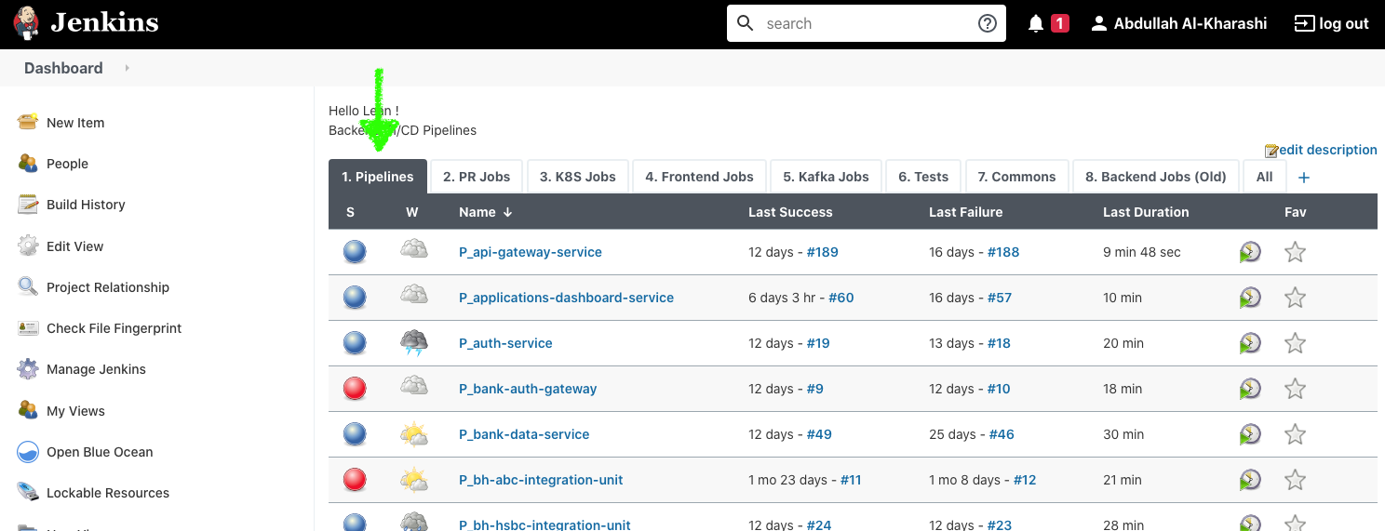
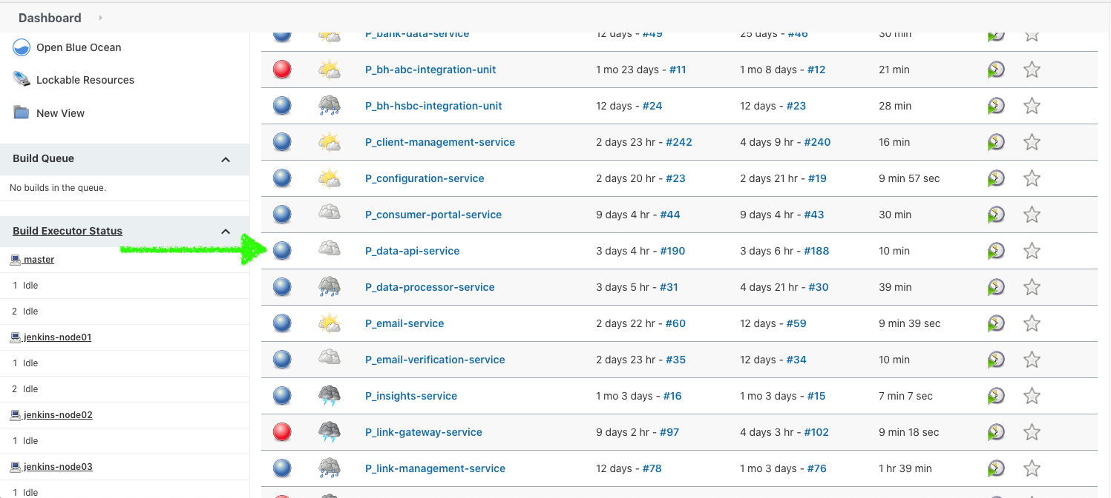
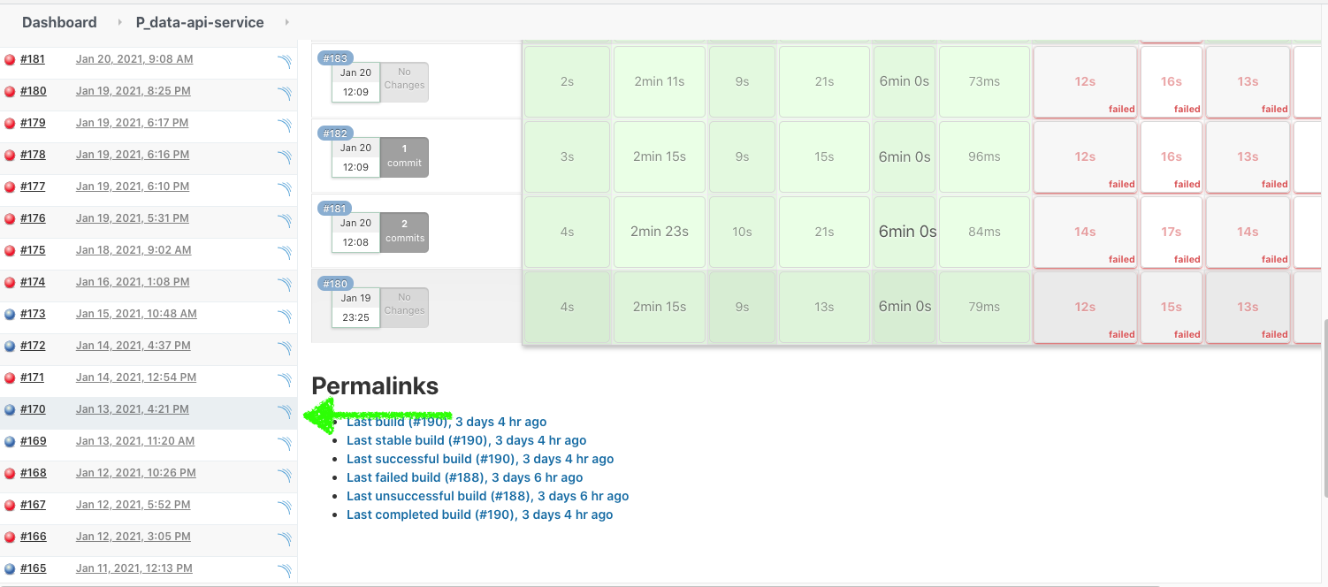
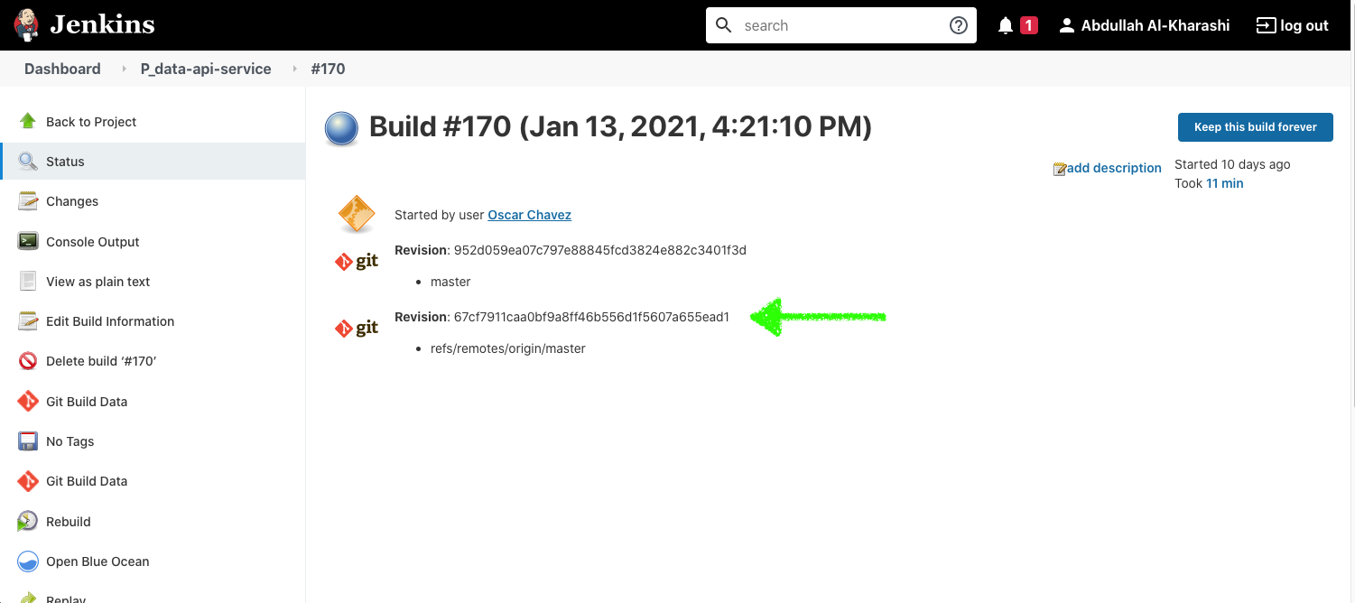
3 Create a new hotfix branch based on the commit ID
4 Once the hotfix is ready, make sure that the service's cloud configuration is in the right state
5 Provide the branch name to DevOps team

